介紹性質：

HOME.Template 1：

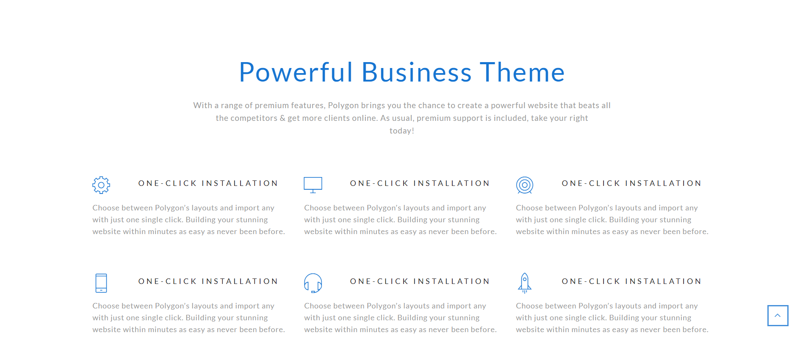

{"title":"產學合作",

"content":"內容",

"block_1":{ "title":"人脈關係", "icon":" ", "content":"人脈關係在之後的合作是非常重要的因素"},

"block_2":{"title":"百大企業", "icon":" ", "content":"我們所合作的企業都是名列國際百大的傑出企業"},

"block_3":{"title":"精準性", "icon":" ", "content":"第一次合作就選擇準確的企業是非常重要的"},

"block_4":{"title":"支援度", "icon":" ", "content":"產學合作的時候，學院一樣提供非常完善的支援與協助"},

"block_5":{"title":"舒適度", "icon":" ", "content":"一家企業的環境以及條件是否完好？"},

"block_6":{"title":"親和力", "icon":" ", "content":"更好的親和力，在職場上帶來的效率會更加提高"}}

HOME.Template 2：

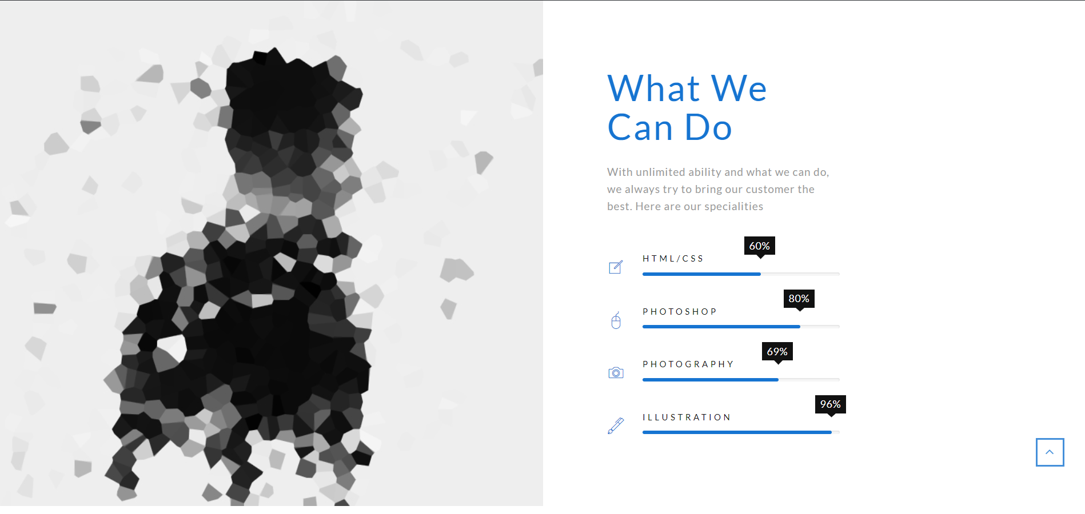

{"title":"企業實習",

"img":" ",

"content":"我們能做什麼呢？等你們來發掘",

"bar_1":{"icon":" ", "name":"網頁設計", "percentage":"60"},

"bar_2":{"icon":" ", "name":"前端工程", "percentage":"50"},

"bar_3":{"icon":" ", "name":"後端製作", "percentage":"30"},

"bar_4":{"icon":" ", "name":"創意無限", "percentage":"90"}}

HOME.Template 3：

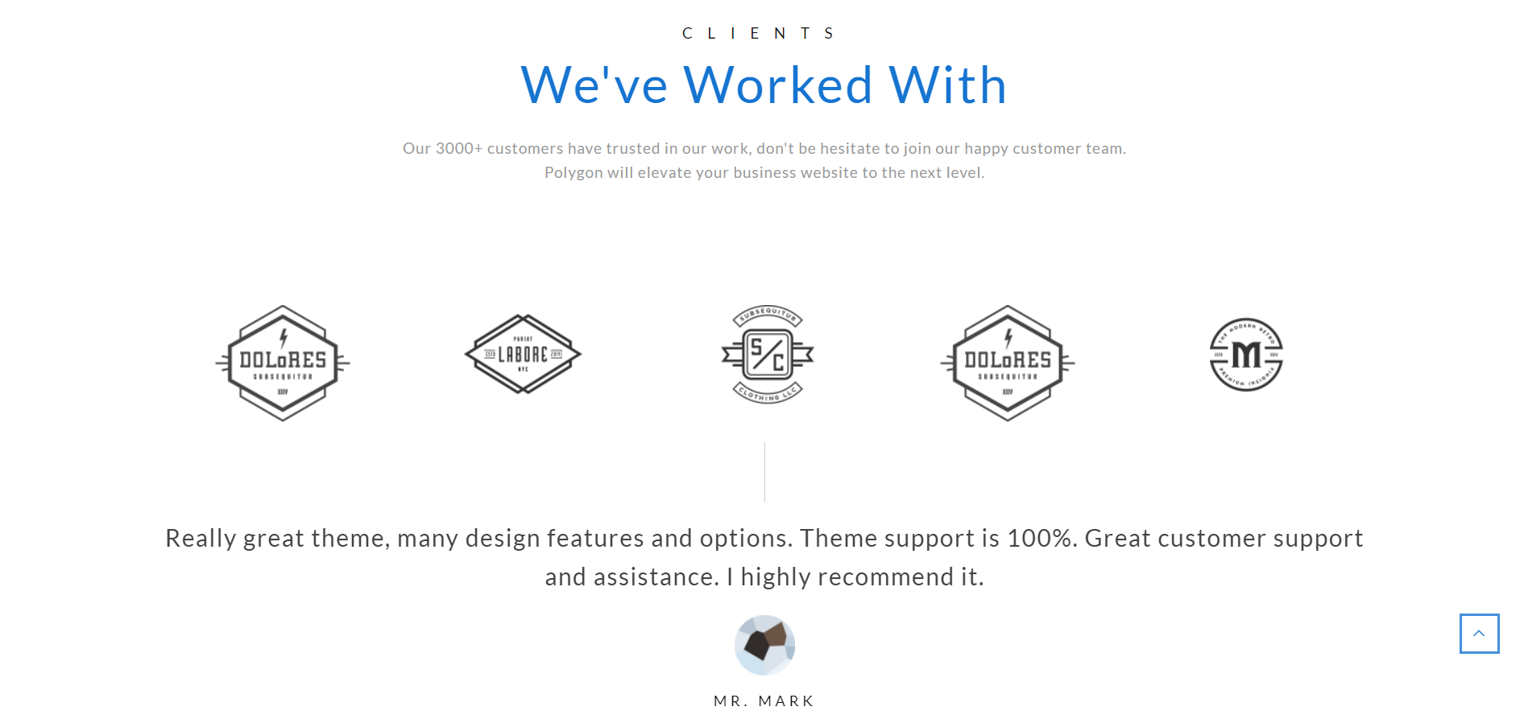

{"title":"數位認證",

"subtitle":"digital certification",

"content":"嚴謹的制度與充實的內容",

"block_1":{"content":"他們很厲害", "writer": "Dell", "position":"總經理", "photo":" "},

"block_2":{"content":"無與倫比的實力與技術", "writer": "Apple", "position":"執行長", "photo":" "},

"block_3":{"content":"這是我見過最傑出的團隊了！", "writer": "Toshiba ", "position":"研發部門", "photo":" "},

"block_4":{"content":"他們若是稱自己為第二，沒人敢稱自己第一", "writer": "ASUS", "position":"董事會", "photo":" "}}

HOME.Template 4：

*10/13更新欄位

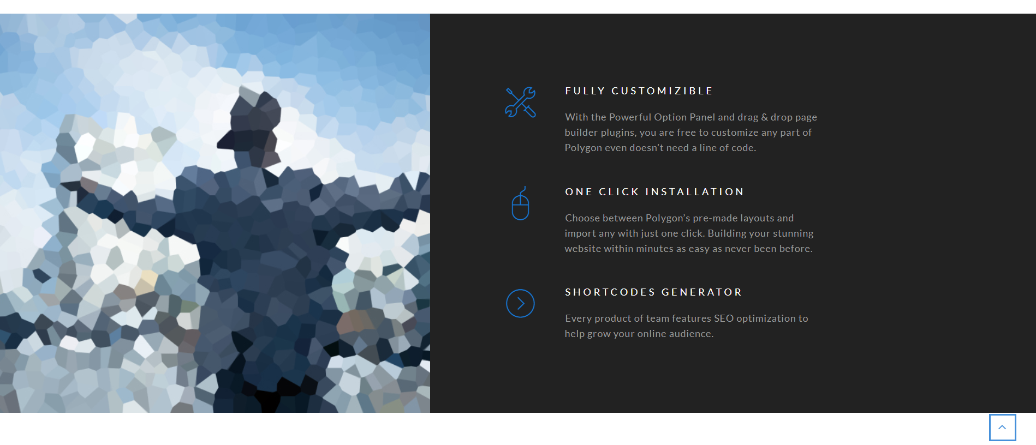

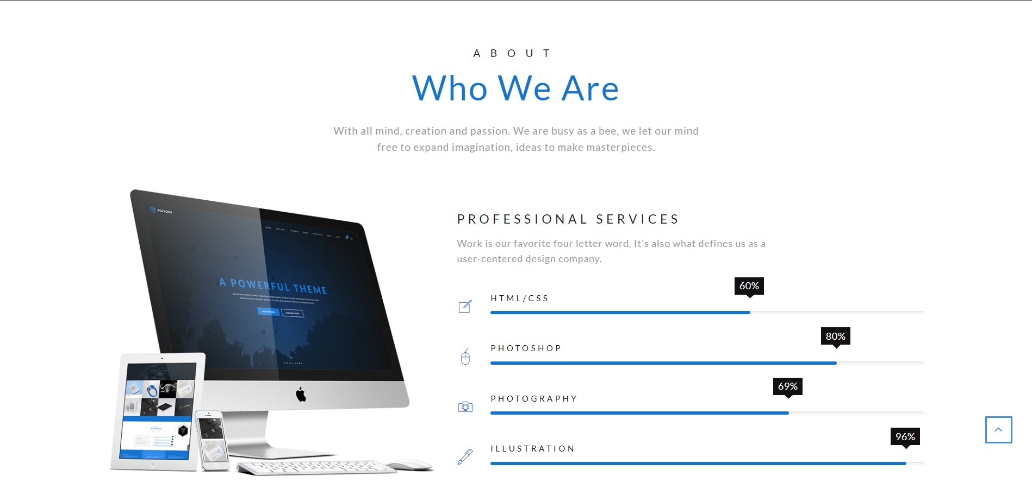

{"img_1":" ",

"block_1":{"title":"合作無間", "icon":" ", "content":"asdfzvxvoieurl"},

"block_2":{"title":"尖閣內容", "icon":" ", "content":"asdfzvxvoieurl"},

"block_3":{"title":"融資困難", "icon":" ", "content":"asdfzvxvoieurl"},

"img_2":" ",

"title":"我們是誰",

"subtitle":"我們就是我們",

"description":"說明部分",

"bar_title":"bar的標題",

"bar_description":"條狀的說明",

"bar_1":{"icon":" ", "name":"網頁設計", "percentage":"60"},

"bar_2":{"icon":" ", "name":"前端工程", "percentage":"50"},

"bar_3":{"icon":" ", "name":"後端製作", "percentage":"30"},

"bar_4":{"icon":" ", "name":"創意無限", "percentage":"90"}}

HOME.Template 5：



{"title":"企業徵才",

"img":" ",

"content":"很多樣很厲害很嚴謹很重要很有用很加分",

"list_title":"為什麼選擇我們？",

"list_1":"12345",

"list_2":"23456",

"list_3":"34567",

"list_4":"45678",

"list_5":"56789",

"list_6":"67890"}

HOME.Template 6：

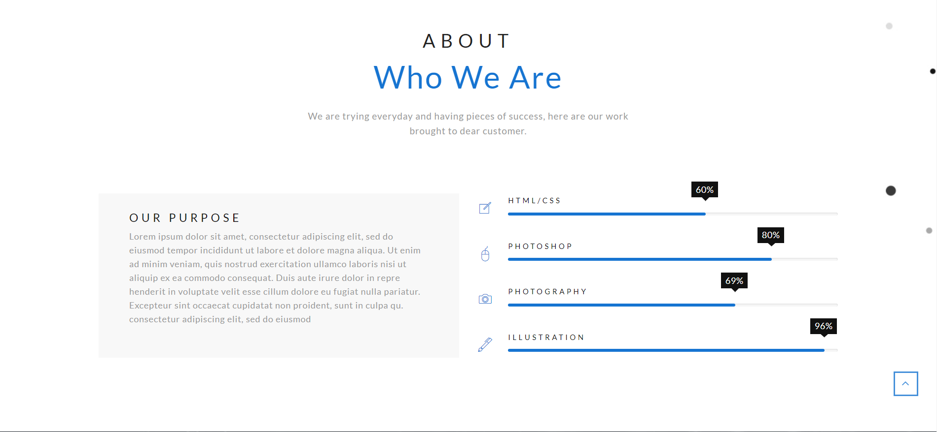

{"title":"我們的目標",

"subtitle":"關於",

"content":"想知道更多嗎？看下去八",

"block":{"title":"我們是誰？", "content":"我們就是我們還是我們於是我們"},

"bar_1":{"icon":" ", "name":"網頁設計", "percentage":"60"},

"bar_2":{"icon":" ", "name":"前端工程", "percentage":"50"},

"bar_3":{"icon":" ", "name":"後端製作", "percentage":"30"},

"bar_4":{"icon":" ", "name":"創意無限", "percentage":"90"}}

HOME.Template 7：

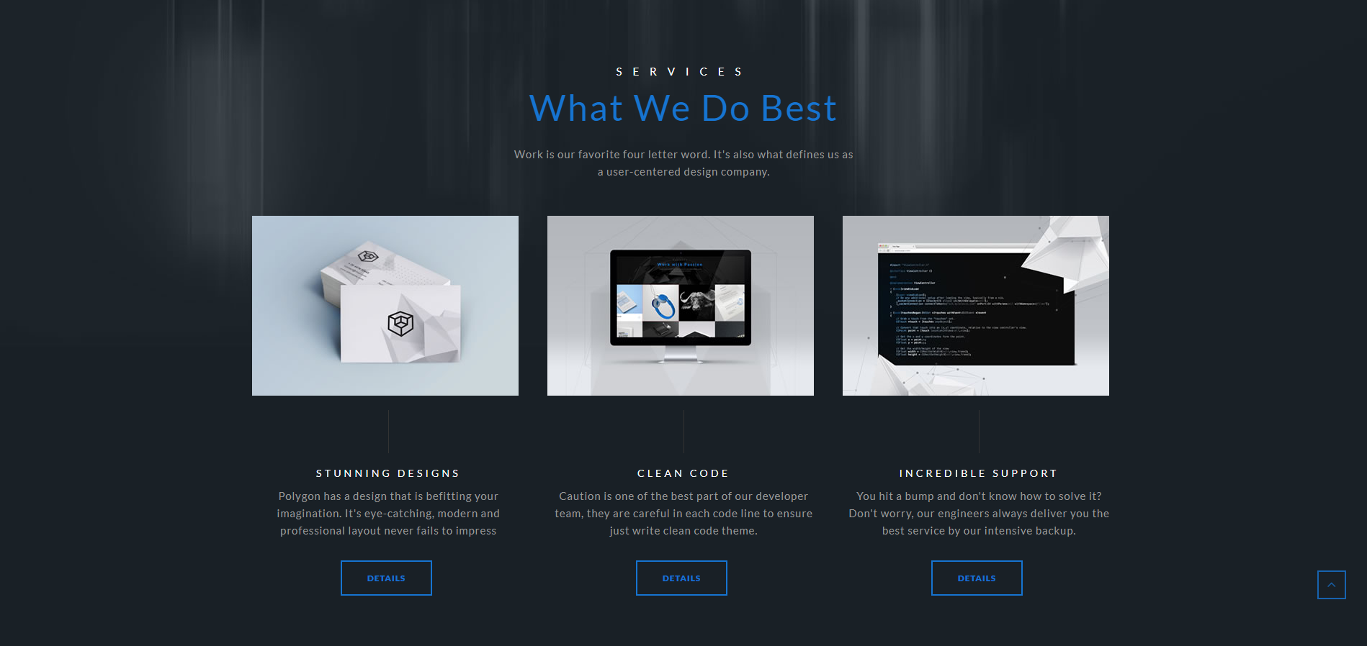

{"title":"我們擅長的事情",

"subtitle":"服務",

"content":"qweruioasdfzxs",

"col_1":{"img":" ", "title":"強力的設計", "content":"哈哈哈哈哈哈"},

"col_2":{"img":" ", "title":"簡潔的程式碼", "content":"拉拉拉拉拉"},

"col_3":{"img":" ", "title":"長久的支持", "content":"兮兮兮兮兮兮兮"}}

HOME.Template 8：

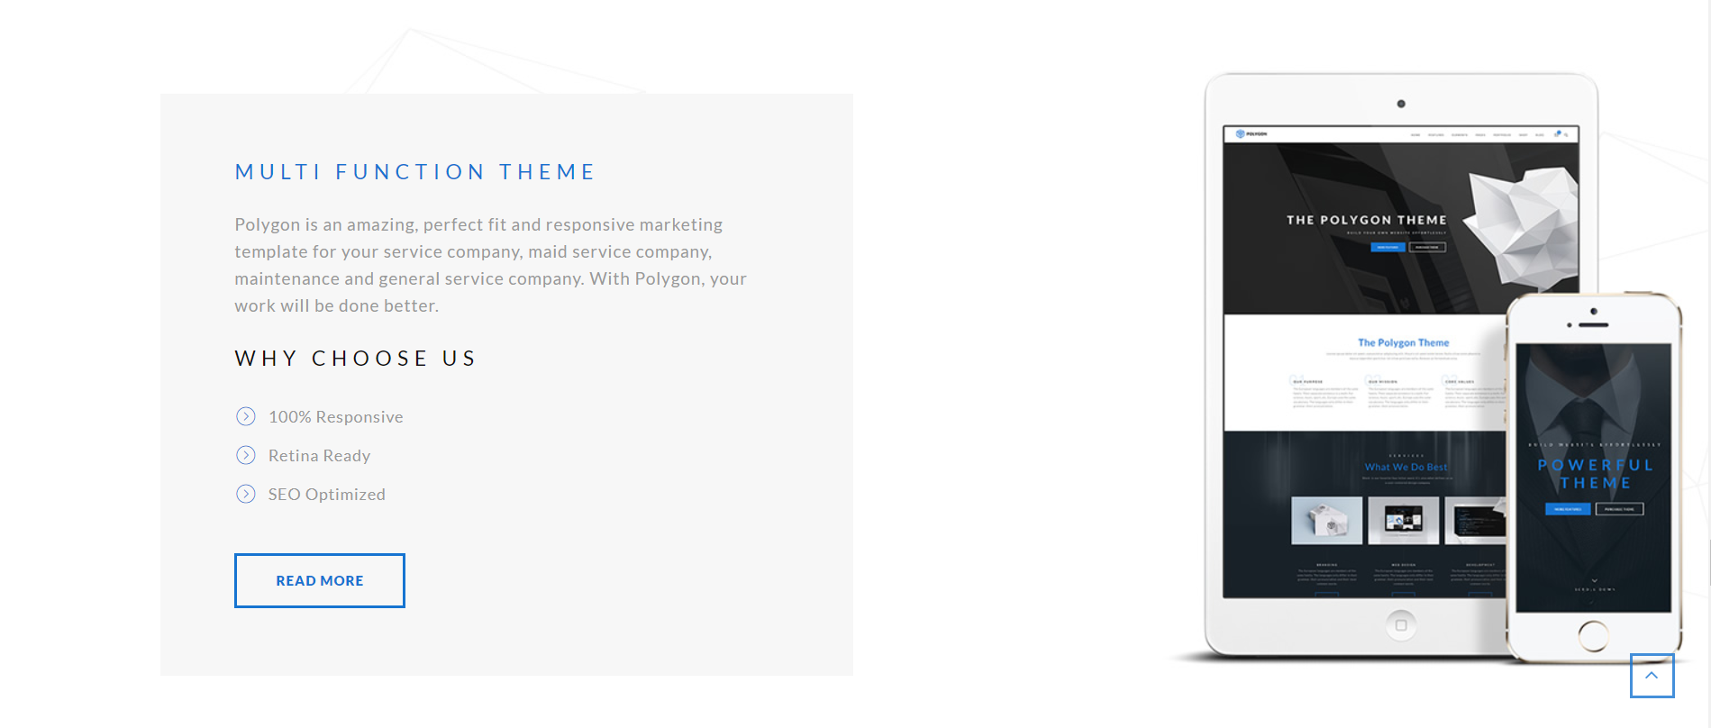{"title":"多樣的主題",

"img":" ",

"content":"我們提供許許多多更種樣式的主題，任由您選擇，可以儘情參考與閱覽，沒有問題的",

"list_title":"為什麼選擇我們？",

"list_1":"RWD設定",

"list_2":"說明完整",

"list_3":"SEO優化"}

HOME.counters:



{

"count_1":{"name": "PROJECT", "number": "134"},

"count_2":{"name": "COFFEE CUPS", "number": "289"},

"count_3":{"name": "AWARDS", "number": "12"},

"count_4":{"name": "CUSTOMERS", "number": "520"},

}

HOME.team:

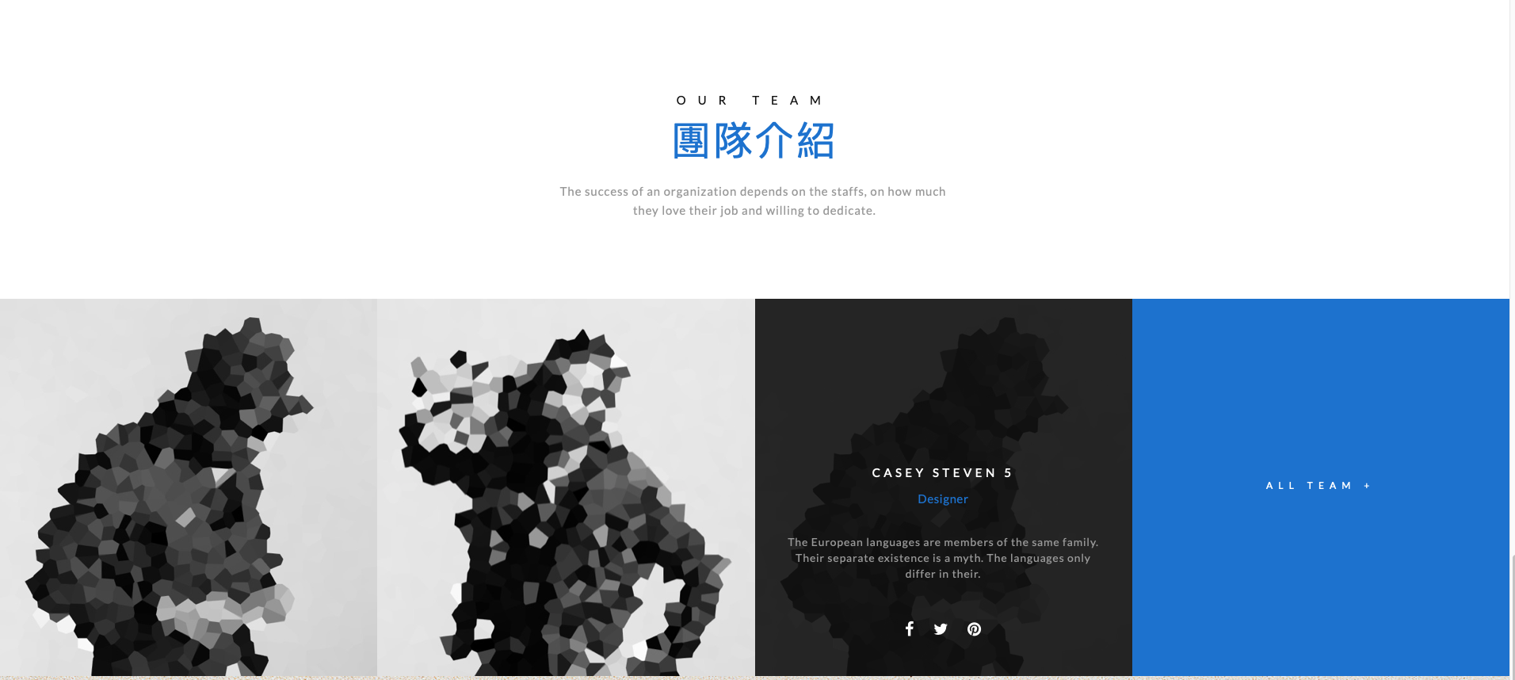

{

"title":"我們的團隊",

"subtitle":"我們的團隊分長的完善且厲害，充滿各式各樣的高手齊聚一堂",

"content":"abcdefghijklmnopqrstuvwxyz",

"person_1":{"name":"路人甲", "role":"老師", "intro":"", "fb_url":"", "img":""},

"person_2":{"name":"路人乙", "role":"設計師", "intro":"", "fb_url":"", "img":""},

"person_3":{"name":"路人丙", "role":"碼農", "intro":"", "fb_url":"", "img":""}

}

INTRO.template_1:



{"title":"我是大標題",

"subtitle":"我是小標題哈哈哈哈哈哈哈哈",

"img":""}

INTRO.template_2:

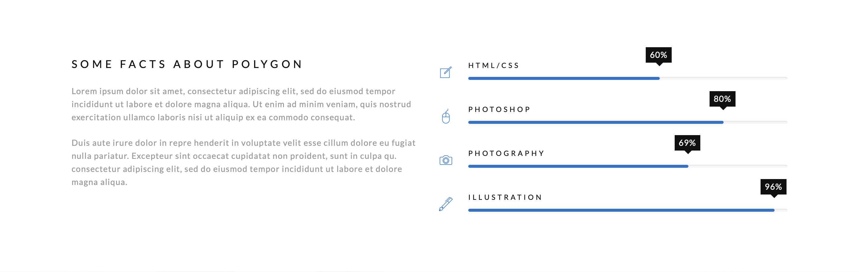

{"title":"標題哈哈哈",

"content":"我是一篇文章",

"bar_1":{"name":"條狀一", "icon":"", "percentage":"25"},

"bar_2":{"name":"條狀二", "icon":"", "percentage":"50"},

"bar_3":{"name":"條狀三", "icon":"", "percentage":"75"},

"bar_4":{"name":"條狀四", "icon":"", "percentage":"100"}}

INTRO.template_3:

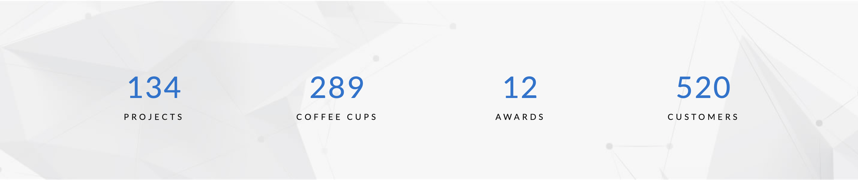

{"count_1":{"name":"專案", "number":"555"},

"count_2":{"name":"合作廠商", "number":"666"},

"count_3":{"name":"經費", "number":"777"},

"count_4":{"name":"學生人數", "number":"888"}}

INTRO.template_4:

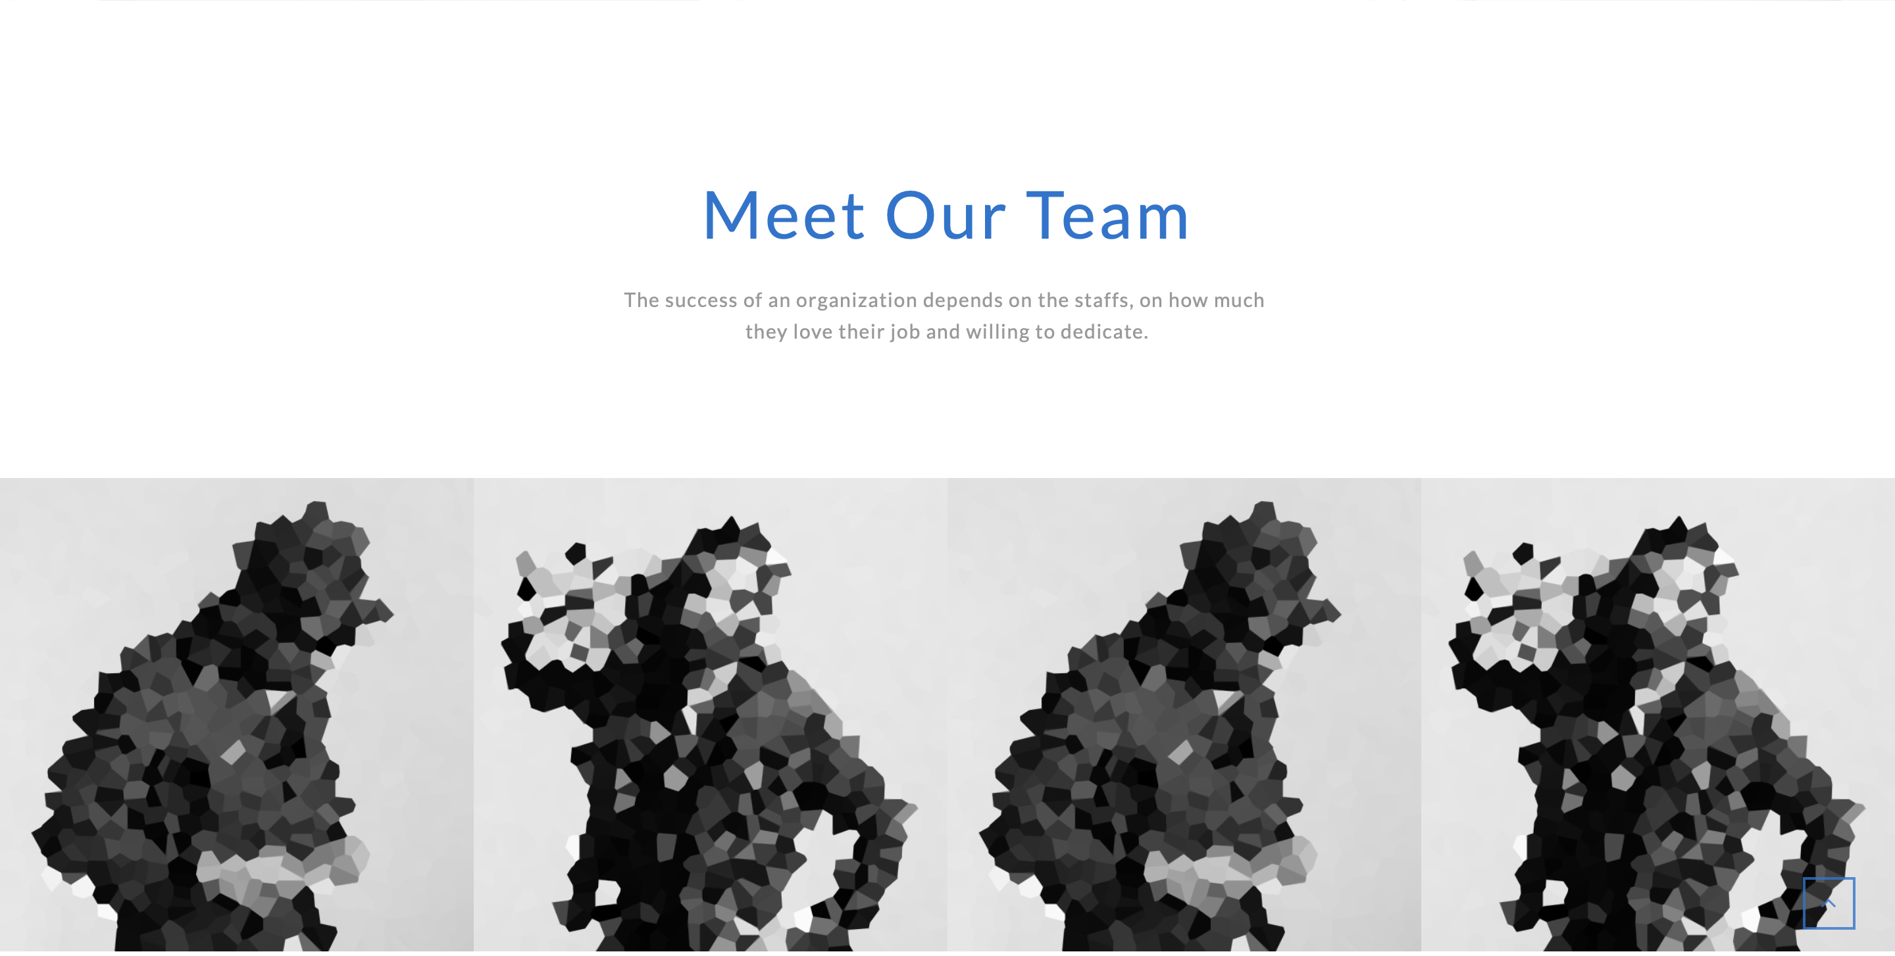

{

"title":"我們的團隊",

"subtitle":"我們的團隊分長的完善且厲害，充滿各式各樣的高手齊聚一堂",

"person_1":{"name":"路人甲", "role":"老師", "intro":"", "fb_url":"", "img":""},

"person_2":{"name":"路人乙", "role":"設計師", "intro":"", "fb_url":"", "img":""},

"person_3":{"name":"路人丙", "role":"碼農", "intro":"", "fb_url":"", "img":""},

"person_4":{"name":"路人丁", "role":"可撥鼠", "intro":"", "fb_url":"", "img":""}

}

INTRO.tempate_5:



{

"block_1":{

"icon":"",

"title":"加油",

"content":"內容一"},

"block_2":{

"icon":"",

"title":"想睡笑",

"content":"內容二"},

"block_3":{

"icon":"",

"title":"你可以的",

"content":"內容三"},

"block_4":{

"icon":"",

"title":"好的模板",

"content":"內容四"},

"block_5":{

"icon":"",

"title":"好作品",

"content":"內容五"},

"block_6":{

"icon":"",

"title":"是在哈囉？",

"content":"內容六"},

}

INTRO.template_6:



{

"call":"想要加入我們嗎？請填以下表單",

"action_name":"報名",

"action_url":"url網址",

}

INTRO.template_7

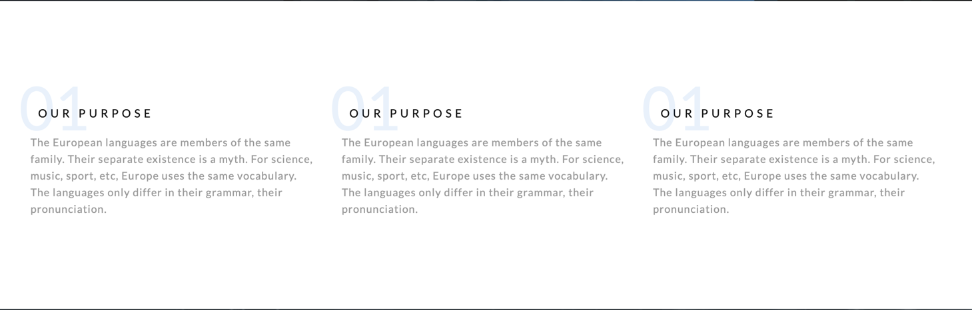

{

"block_1":{"title":"標題一", "content":"內容一"},

"block_2":{"title":"標題二", "content":"內容二"},

"block_3":{"title":"標題三", "content":"內容三"}

}

INTRO.template_8



{

"block_1":{

"title":"afaswer",

"content":"qwerwrq",

"url_name":"Google",

"url":"www.google.com"

},

"block_2":{

"title":"afaswer",

"content":"qwerwrq",

"url_name":"facebook",

"url":"www.facebook.com"

},

"block_3":{

"title":"afaswer",

"content":"qwerwrq",

"url_name":"yahoo",

"url":"www.yahoo.com"

}

}

INTRO.template_9

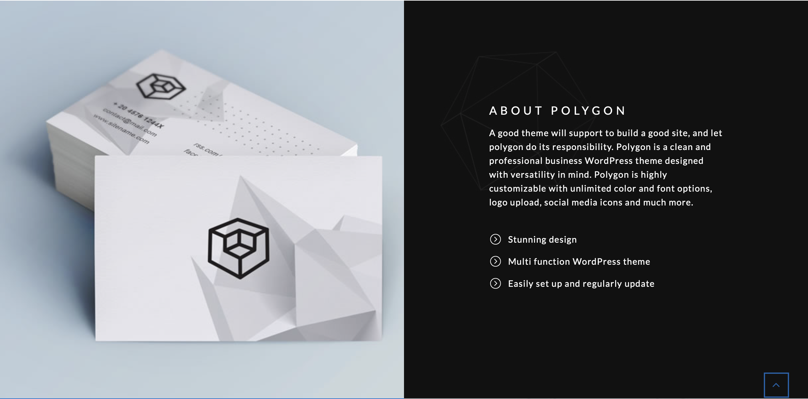

{

"img":"",

"title":"標題",

"content":"內容",

"list_1":"1",

"list_2":"2",

"list_3":"3"

}

INTRO.template_10

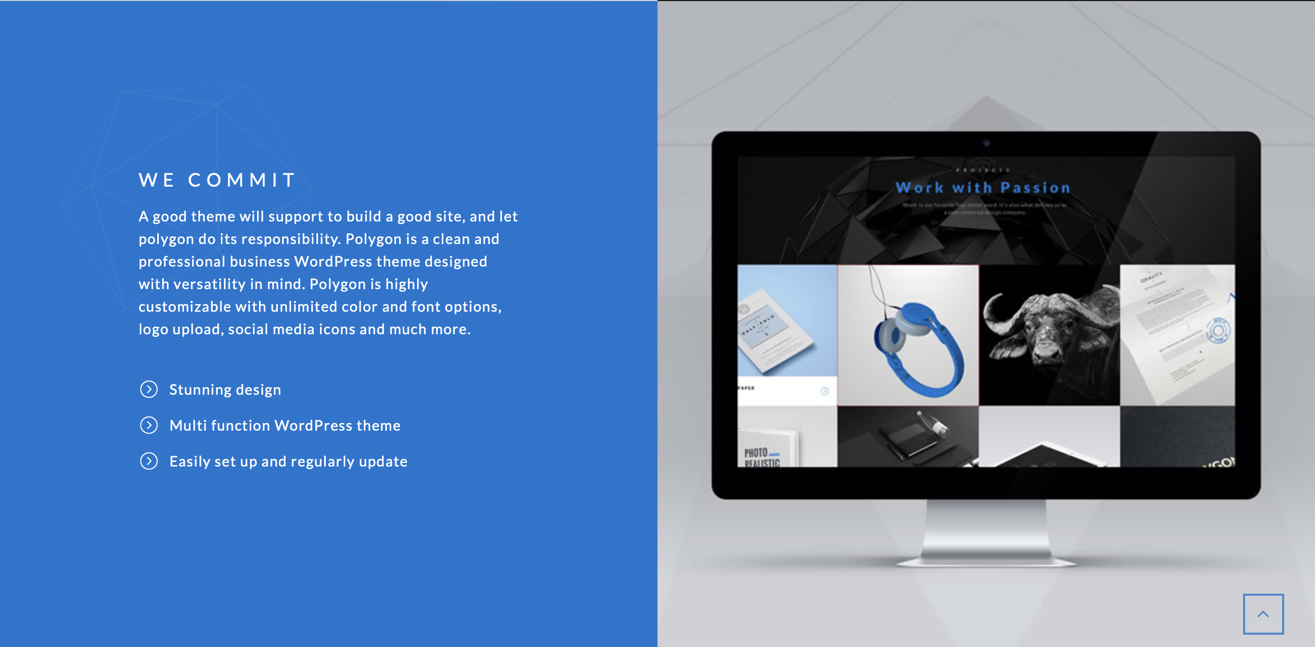

{

"img":"",

"title":"標題",

"content":"內容",

"list_1":"1",

"list_2":"2",

"list_3":"3"

}